**APPLICATION LOAD BALNCERS IN AWS**

|  |  |  |  |
| --- | --- | --- | --- |
| **Chapter No** | **TITLE** | | **Page No.** |
|  | **LIST OF FIGURES** | | 1 |
|  | **ABSTRACT** | | 2 |
| 1 | **INTRODUCTION**   * 1. Overview | | 3-4 |
| 2 | **LITERATURE SURVEY** | | 5 |
| 3 | **REQUIREMENTS ANALYSIS** | |  |
|  | 3.1 | Objective | 6 |
|  | 3.2 | 3.2.1 Hardware Requirements  3.2.2 Software Requirements | 7 |
| 4 | **AIM AND SCOPE OF THE PRESENT INVESTIGATION** | | 8-17 |
|  | 4.1 | AIM  SCOPE OF THE PRESENT INVESTIGATION | 8 |
|  | 4.2 | EXPERIMENTAL OR SERVICES/MATERIALS USED AND METHOD | 9-17 |
|  | 4.3 | 4.3.1 Web Application | 18 |
| 5 | **CONCLUSION** | | 19 |
|  | **REFERENCES** | | 20 |

**LIST OF FIGURES**

**Figure No. Figure Name Page No.**

1.1 System Archieture4

4.2.1 Open EC2 9

4.2.2 Create Instance 9

4.2.3 Linux 10

4.2.4 Create Key-Pair 10

4.2.5 Launch Instance 11

4.2.6 Connect to Text Edit 12

4.2.7 Linux CMD 13

4.2.8 Create target group 13

4.2.9 Create ALB 14

4.2.10 Launch ALB 14

4.3.1 Home Page 15

1

**ABSTRACT**

An application load balancer is a critical component of modern network architecture, designed to efficiently distribute incoming traffic across multiple servers or resources. It acts as a traffic cop, ensuring that each server receives an appropriate share of requests, optimizing performance, and enhancing reliability.

A load balancer serves as the single point of contact for clients. Clients send requests to the load balancer, and the load balancer sends them to targets, such as EC2 instances. To configure your load balancer, you create target groups, and then register targets with your target groups. You also create listeners to check for connection requests from clients, and listener rules to route requests from clients to the targets in one or more target groups

When a client makes a request to our application, the listeners in our AWS Application Load Balancer will receive requests matching the protocol and port we configure.

The receiving listener will evaluate the incoming request against the rules we specify, and if applicable, will route the request to the appropriate target group. We can use an HTTPS listener to offload the work of TLS encryption and decryption to our load balancer. Healthy targets in one or more target groups receive traffic based on the load balancing algorithm, and the routing rules we specify in the listener.

Application Load Balancer operates at the request level (layer 7), routing traffic to targets (EC2 instances, containers, IP addresses, and Lambda functions) based on the content of the request. Ideal for advanced load balancing of HTTP and HTTPS traffic, Application Load Balancer provides advanced request routing targeted at delivery of modern application architectures, including micro services and container-based applications. Application Load Balancer simplifies and improves the security of your application, by ensuring that the latest SSL/TLS ciphers and protocols are used at all times

This abstract explores about the application load balancers, and their roles and how it works and how it is used.

*KEY WORDS:* Instances, Elastic Load Balancers, Application Load Balancers.

2

**CHAPTER 1**

**INTRODUCTION**

* 1. **OVERVIEW**

Let us discuss about the overview of components.

**Cloud Computing:** Cloud computing is the on-demand availability of computers, especially data storage cloud storage and computing power, without direct active management by the user. Large clouds often have functions distributed over multiple locations, each of which is a data center. Cloud computing relies on sharing of resources to achieve coherence and typically uses a pay-as-you-go model, which can help in reducing capital expenses but may also lead to unexpected operating expenses  for users.

**AWS:** Amazon Web Services, Inc. is a subsidiary of Amazon that provides on-demand cloud computing platforms and APIs to individuals, companies, and governments, on a metered, pay-as-you-go basis. Clients will often use this in combination with autoscaling.

**Instance:** You can run multiple virtual machines on a single computer, but when you run virtual machines in the cloud environment, they are known as instances. Running virtual machines on the cloud allows organizations to benefit from the cost-effectiveness of sharing and scaling resources.

**Load Balancer:**  The load balancer serves as the single point of contact for clients. The load balancer distributes incoming application traffic across multiple targets, such as EC2 instances, in multiple Availability Zones. This increases the availability of your application.

**Application Load Balancer:**Application Load Balancer  (ALB) is a fully managed layer 7 load balancing service that load balances incoming traffic across multiple targets, such as Amazon EC2 instances. ALB supports advanced request routing features based on parameters like HTTP headers and methods, query string, host and path based routing.

3

**Web Application:** A web application is software that runs in your web browser. Businesses have to exchange information and deliver services remotely. They use web applications to connect with customers conveniently and securely.

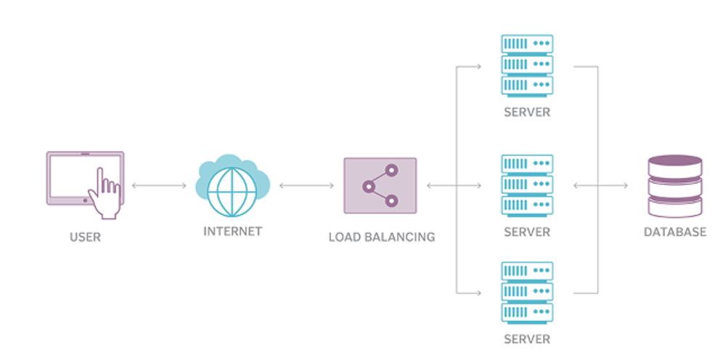

**FIG -1.1 SYSTEM ARCHIETURE OF APPLICATION LOAD BALANCERS**

4

**CHAPTER 2**

**LITERATURE REVIEW**

1)Einollah Jafarnejad Ghomi, Amir Masoud Rahmani, Nooruldeen Nasih Qader

Journal of Network and Computer Applications 88, 50-71, 2017

Cloud computing is a modern paradigm to provide services through the Internet. Load balancing is a key aspect of cloud computing and avoids the situation in which some nodes become overloaded while the others are idle or have little work to do. Load balancing can improve the Quality of Service (QoS) metrics, including response time, cost, throughput, performance and resource utilization. We provide insights into the identification of open issues and guidelines for future research.

2) Dalia Abdulkareem Shafiq, Noor Zaman Jhanjhi, Azween Abdullah, Mohammed A Alzain

IEEE Access 9, 41731-41744, 2021

Despite the many past research conducted in the Cloud Computing field, some challenges still exist related to workload balancing in cloud-based applications and specifically in the Infrastructure as service (IaaS) cloud model. Efficient allocation of tasks is a crucial process in cloud computing due to the restricted number of resources/virtual machines. IaaS is one of the models of this technology that handles the backend where servers, data centers, and virtual machines are managed.It also achieves good performance in terms of less Execution time and Makespan.

**5**

**CHAPTER 3**

**REQUIREMENTS ANALYSIS**

**3.1. OBJECTIVE OF THE PRODUCT**

The primary objective of working with Application Load Balancers in AWS is to ensure that web applications and services are highly available, scalable, secure, and performant, while also optimizing resource utilization and operational efficiency in the cloud environment. By creating Application Load Balancers to reduce the server traffic. This is the primary aim of the project is to reduce server overloading in farmers website.

6

**3.2. REQUIREMENTS**

**3.2.1.HARDWARE REQUIREMENTS**

* Operating System : Windows 11
* Ram : 8 GB
* SSD : 512GB
* Processor : Ryzen 5

**3.2.2. SOFTWARE REQUIREMENTS**

* Software’s : AWS Console
* Web Application : HTML, CSS, JavaScript

7

# **CHAPTER 4**

**4.1.AIM AND SCOPE OF THE PRESENT INVESTIGATION**

**AIM:**

To create Application Load Balancers in AWS.

**SCOPE OF THE INVESTIGATION:**

An Application Load Balancer functions at the application layer, the seventh layer of the Open Systems Interconnection (OSI) model. After the load balancer receives a request, it evaluates the listener rules in priority order to determine which rule to apply, and then selects a target from the target group for the rule action. You can configure listener rules to route requests to different target groups based on the content of the application traffic. Routing is performed independently for each target group, even when a target is registered with multiple target groups. You can configure the routing algorithm used at the target group level. The default routing algorithm is round robin; alternatively, you can specify the least outstanding requests routing algorithm.

You can add and remove targets from your load balancer as your needs change, without disrupting the overall flow of requests to your application. Elastic Load Balancing scales your load balancer as traffic to your application changes over time. Elastic Load Balancing can scale to the vast majority of workloads automatically.

You can configure health checks, which are used to monitor the health of the registered targets so that the load balancer can send requests only to the healthy targets.

8

**4.2. EXPERIMENTAL OR SERVICES/MATERIALS USED AND METHOD:**

**CREATION AND IMPLEMENTATION OF APPLICATION LOAD BALANCERS**

**Step-1:**

Select EC2 from the Services Menu.

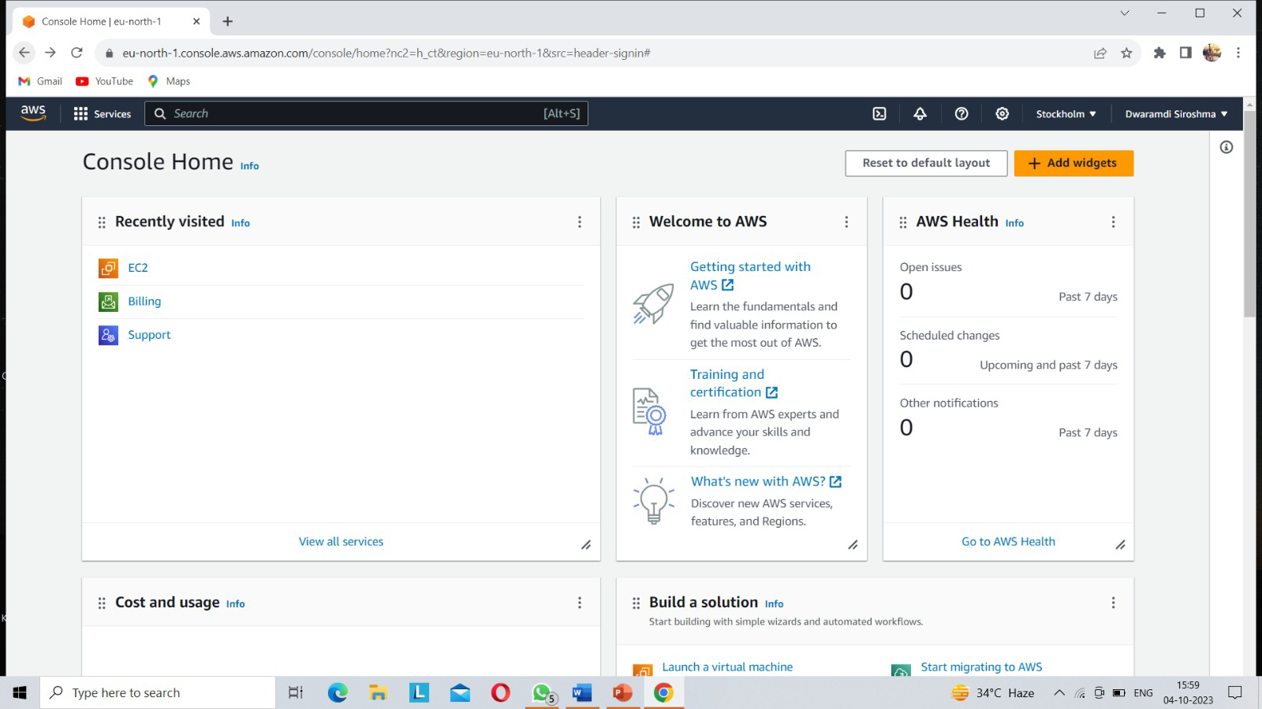

**FIG-4.2.1 OPEN EC2**

**Step-2:**

Select Launch Instance and Create an EC2 Instance.

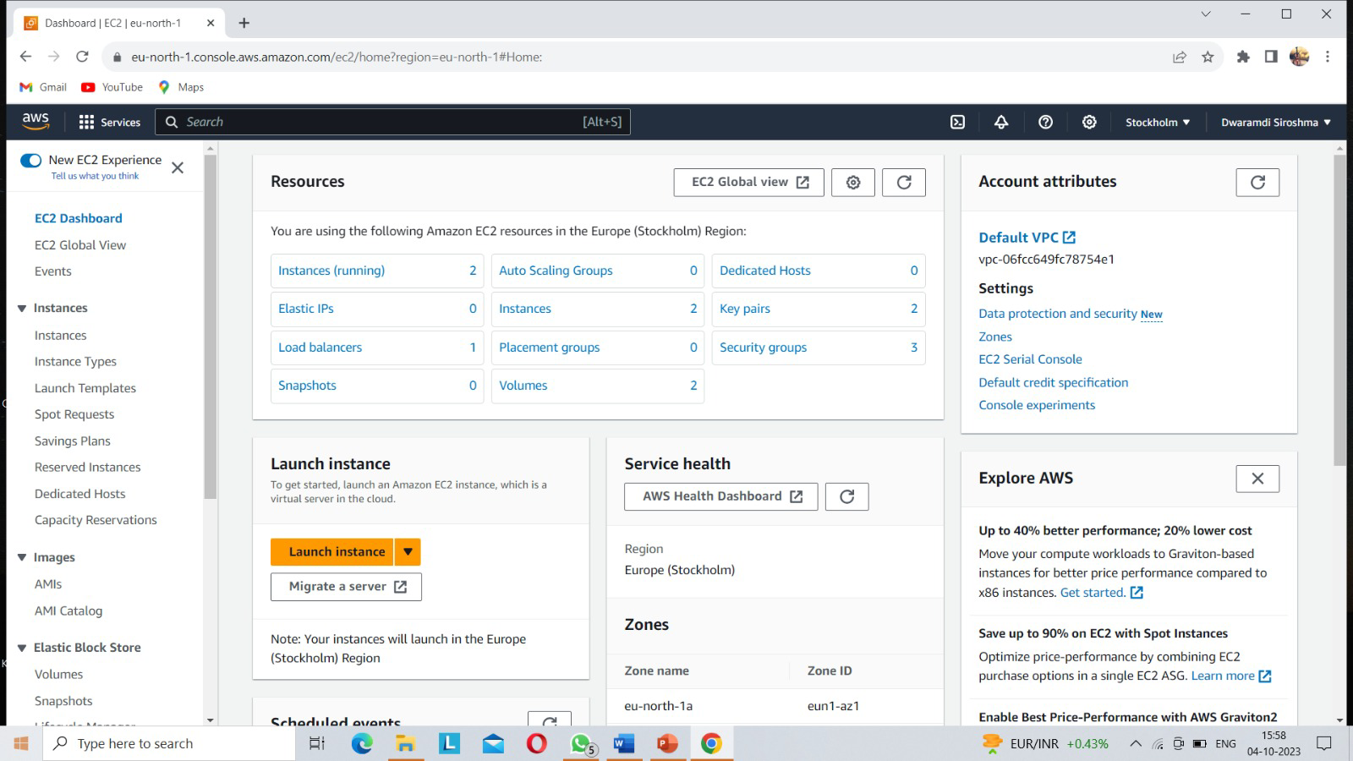

**FIG-4.2.1 CREATE INSTANCE**

**9**

**Step-3:**

Choose appropriate OS. I have used AWS Linux

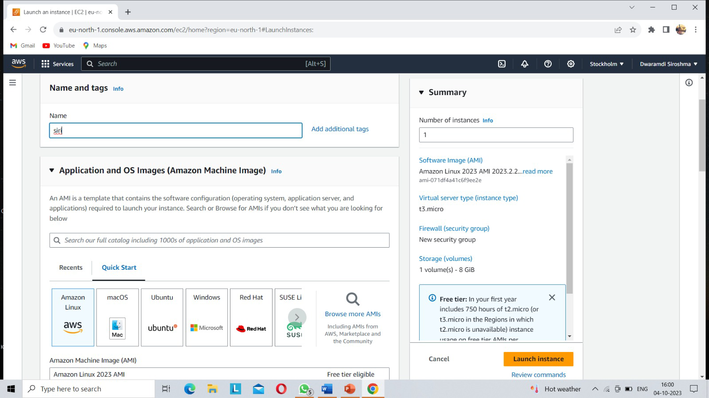

**FIG-4.2.3-LINUX**

**Step-4:**

Create a Key Pair. (This .pem/ppk file will be the specific key whose presence will enable you to login from anywhere)

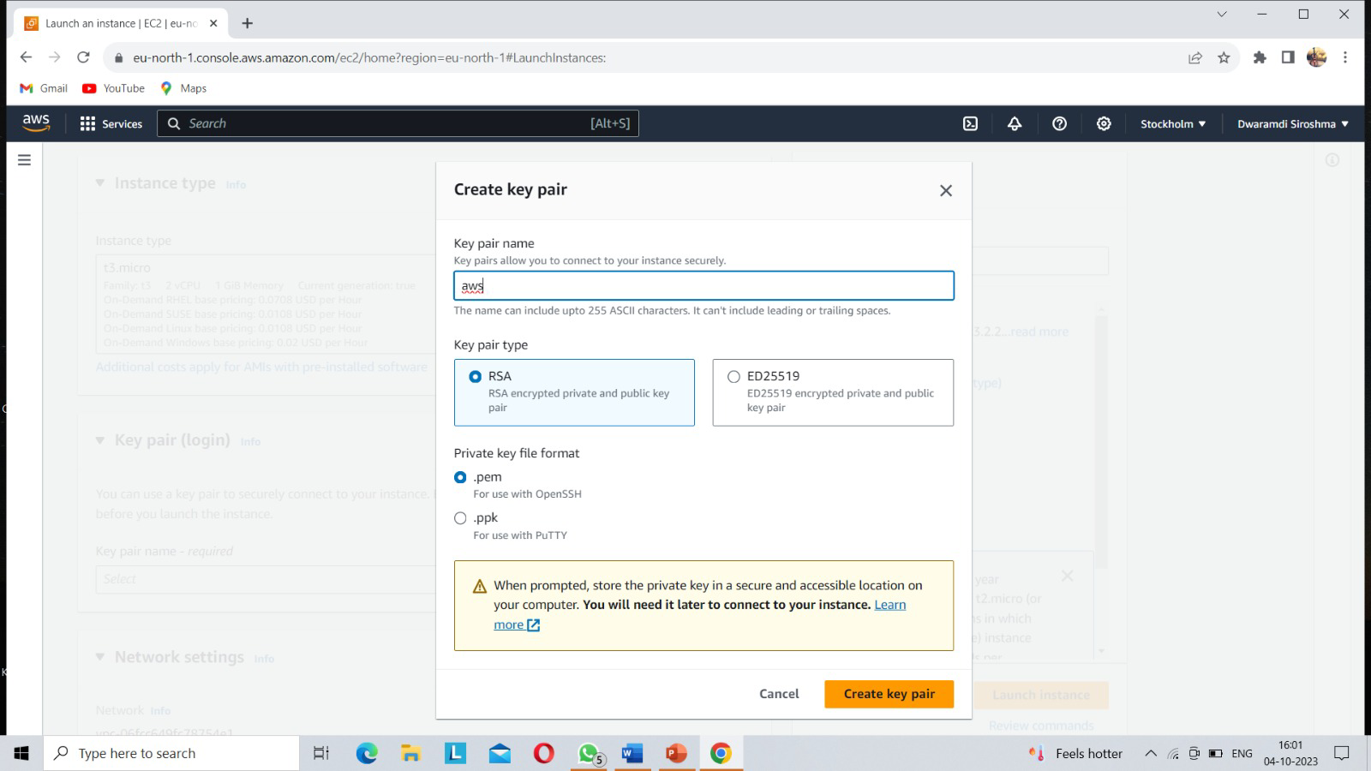

**FIG-4.3.4-CREATE KEYPAIR**

10

**Step-5:**

We have successfully created & launched the instance

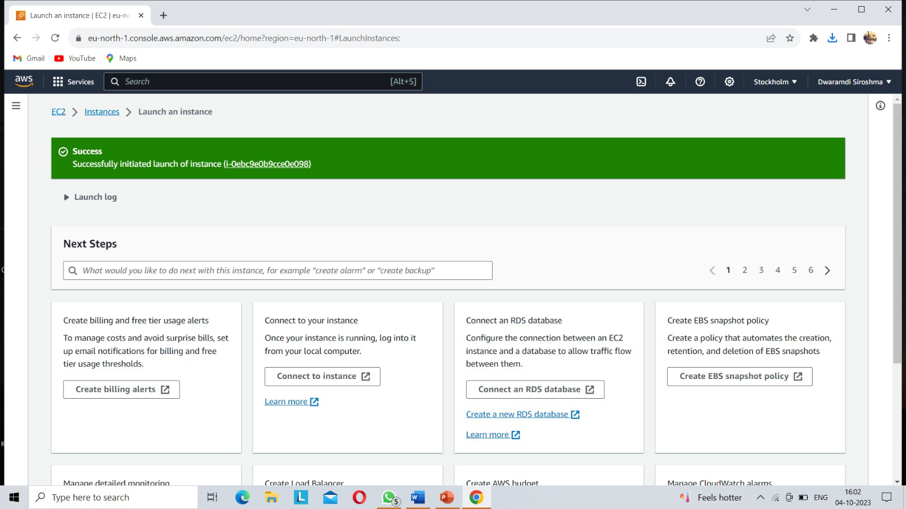

**FIG-4.2.5-LAUNCH INSTANCE**

**Step-6:**

After initializing the EC2 Instance, we will have to connect it to the VM. For this we have three methods.

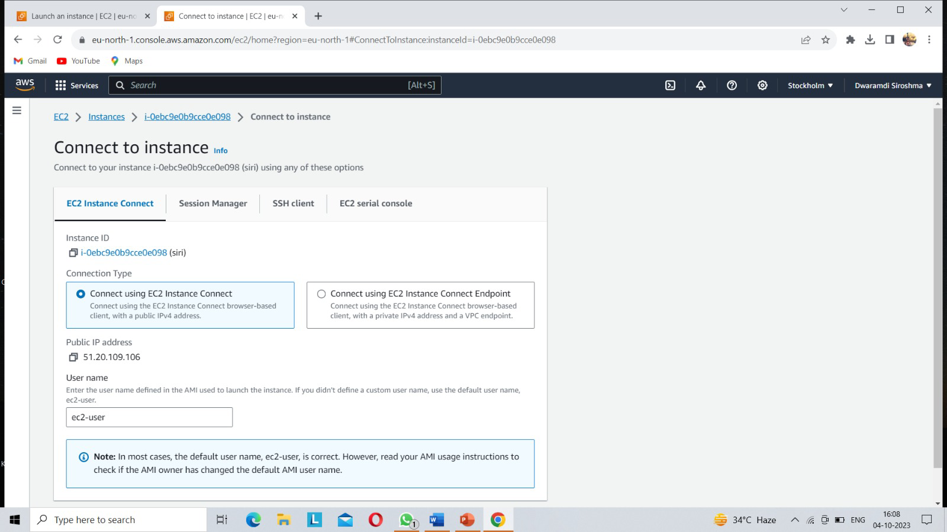

**FIG-4.2.6-CONNECT TO TEXT EDIT**

1. We will use the PuTTY to convert .pem file(The key which we downloaded while creating the instance) to .ppk and launch it on our local System/machine

11

2. If we have downloaded the .ppk file then we can directly initialize the VM on our local Machine/System.

3. We will directly connect to the VM through the AWS platform I have used the 3rd method.

**Step-7:**

After connecting with the Instance, we will run the following commands on the console

1. sudo su –

2. yum update -y

3. yum install -y httpd

4. systemctl status httpd

5. mkdir aws_assg3

6. cd aws_assg3

7.For this assignment we have created a portfolio website which we have uploaded on Github.com.

8.Copy the Download Link for the .zip file of the portfolio

9. using the wget command, download the zip file to the folder.

10. unzip the master.zip file and navigate in to the ShreyasKulkarni_Portfolio-master folder using the cd command.

11. move all the contents from the folder to “/var/www/html/”

-> Edit the Inbound Rules

-> check the status of httpd and then enable & start httpd using the following commands

systemctl status httpd

systemctl enable httpd

12

systemctl start httpd

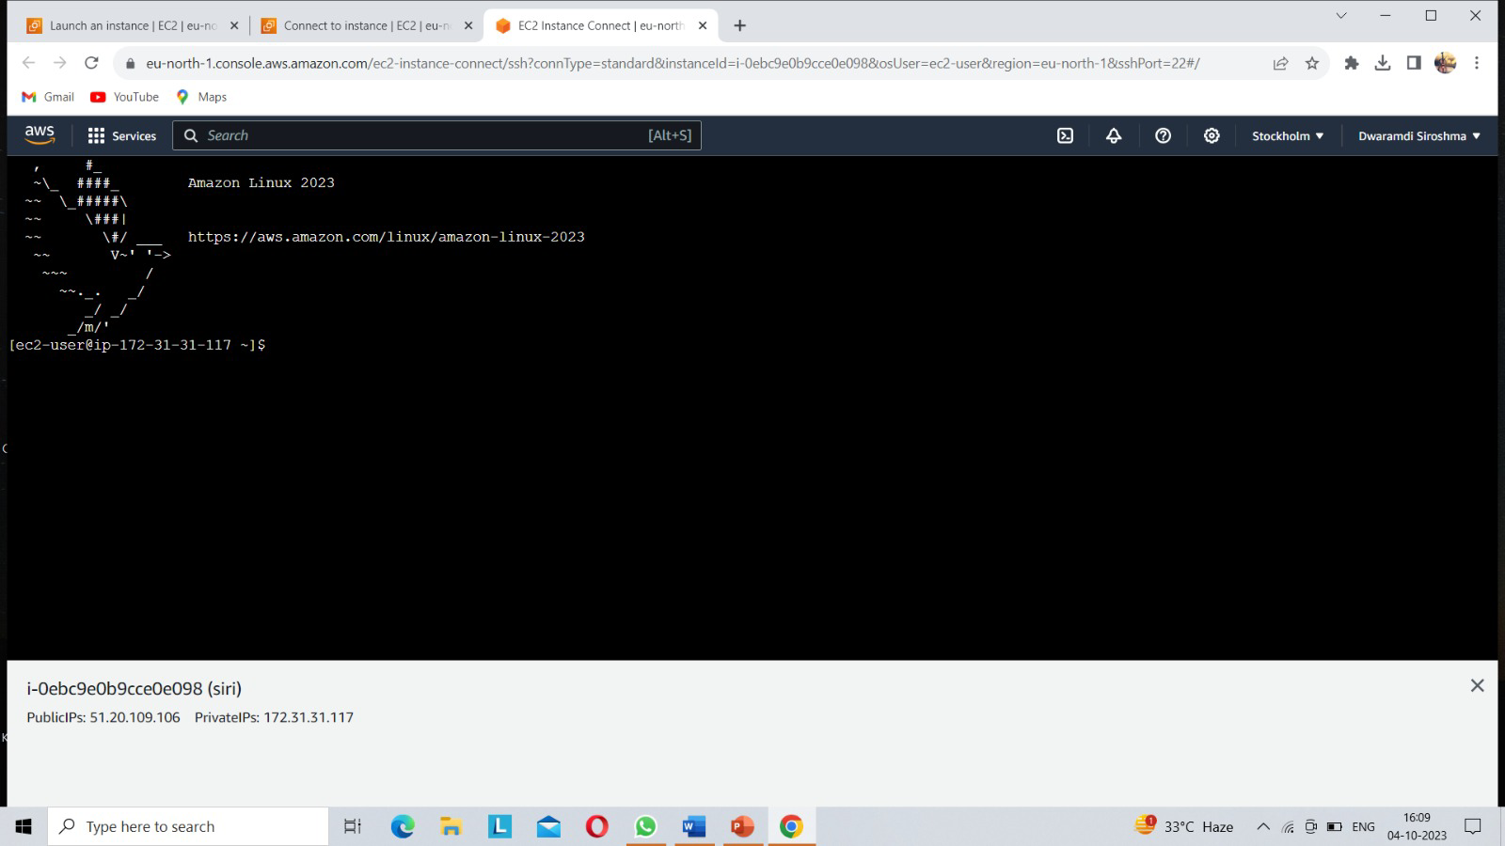

**FIG-4.2.7-LINUX CMD**

**Step-8:**

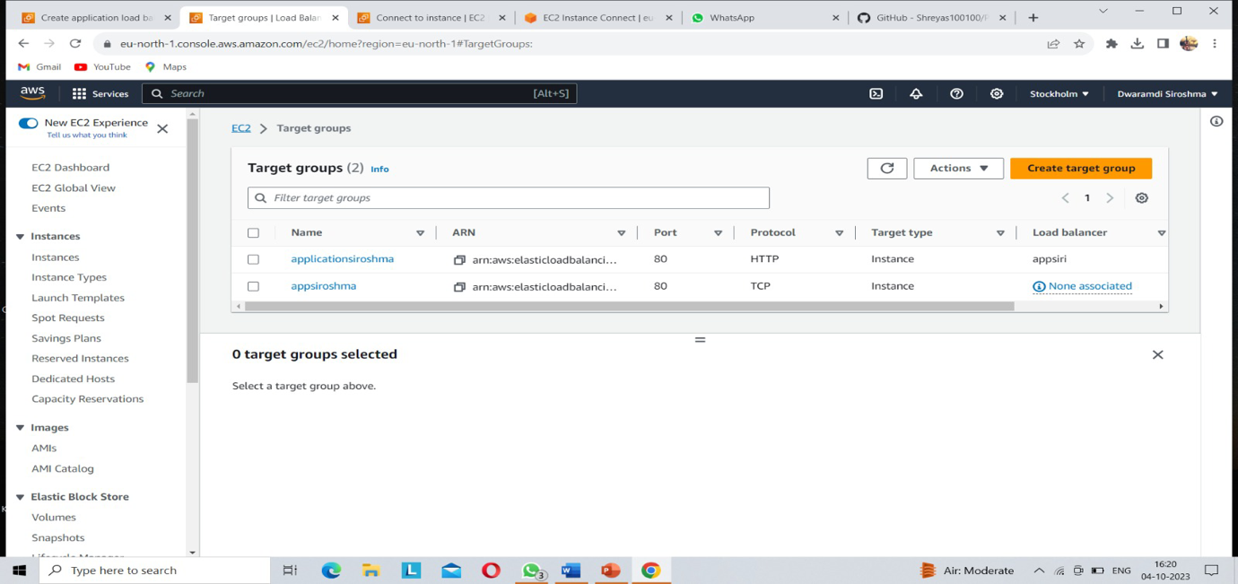Create a target group

13

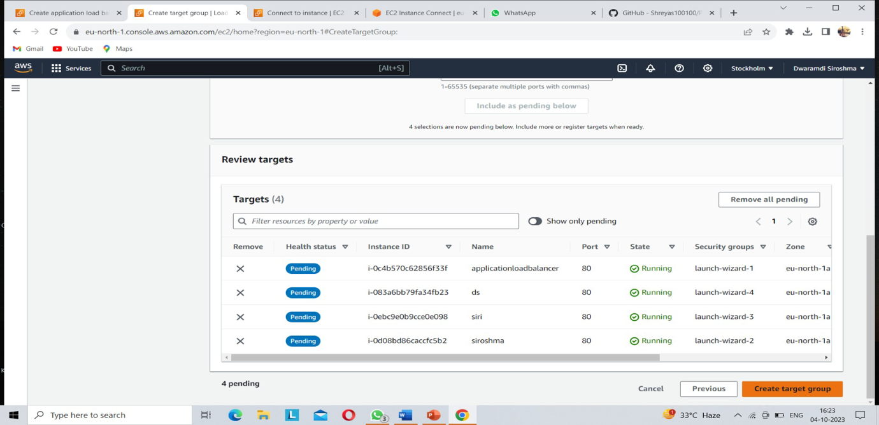

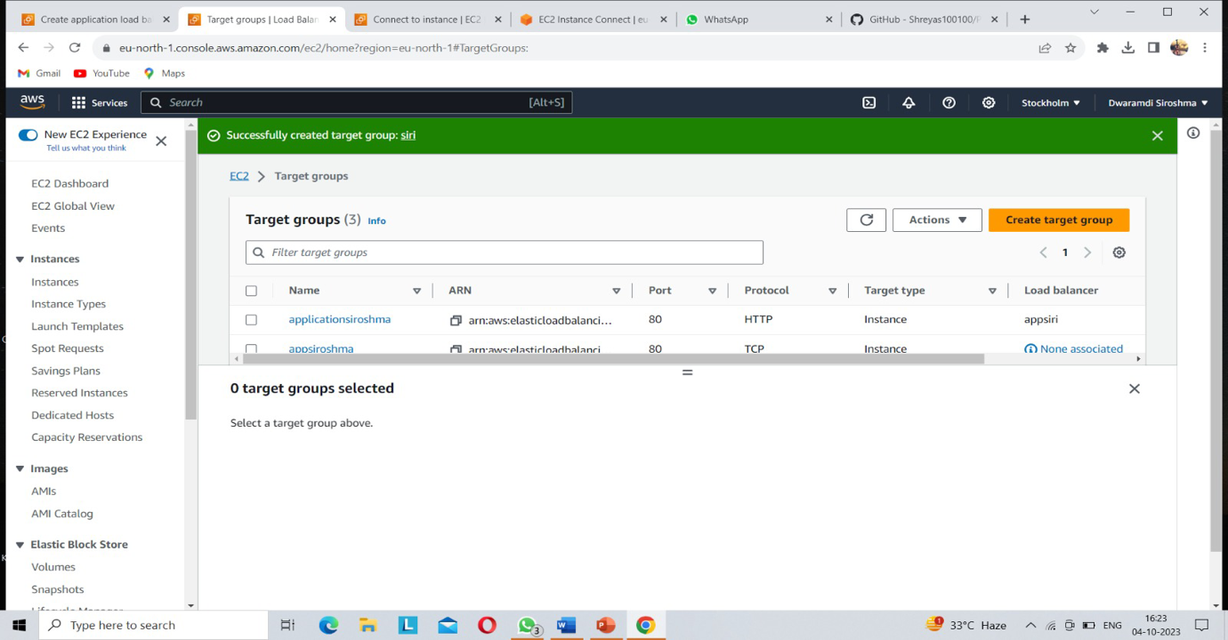

**FIG-4.2.8-SUCCESSFULLY CREATED TARGET GROUP**

14

**Step-9:**

Creation of application load balancer.

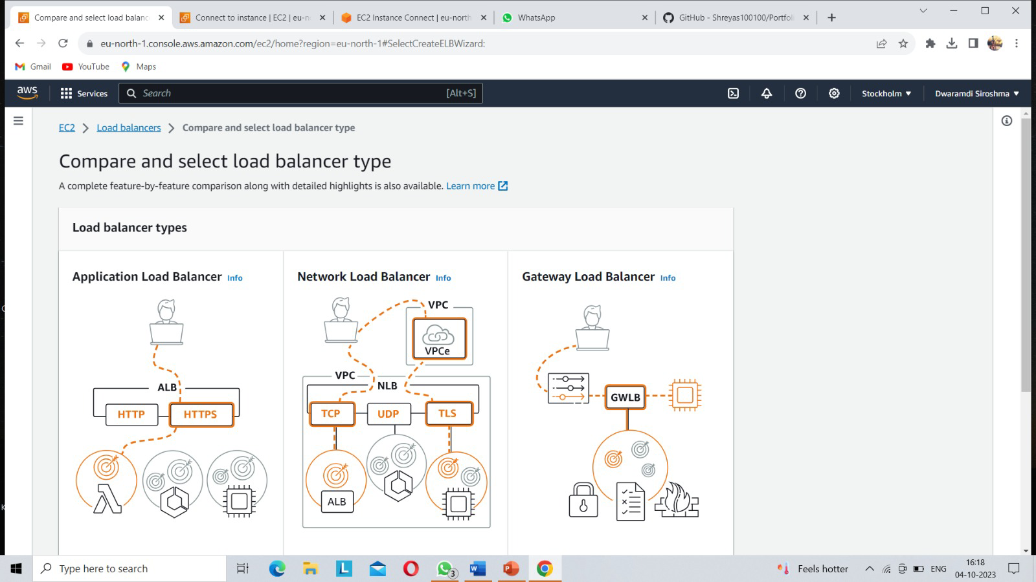

**FIG-4.2.9-CREATE ALB**

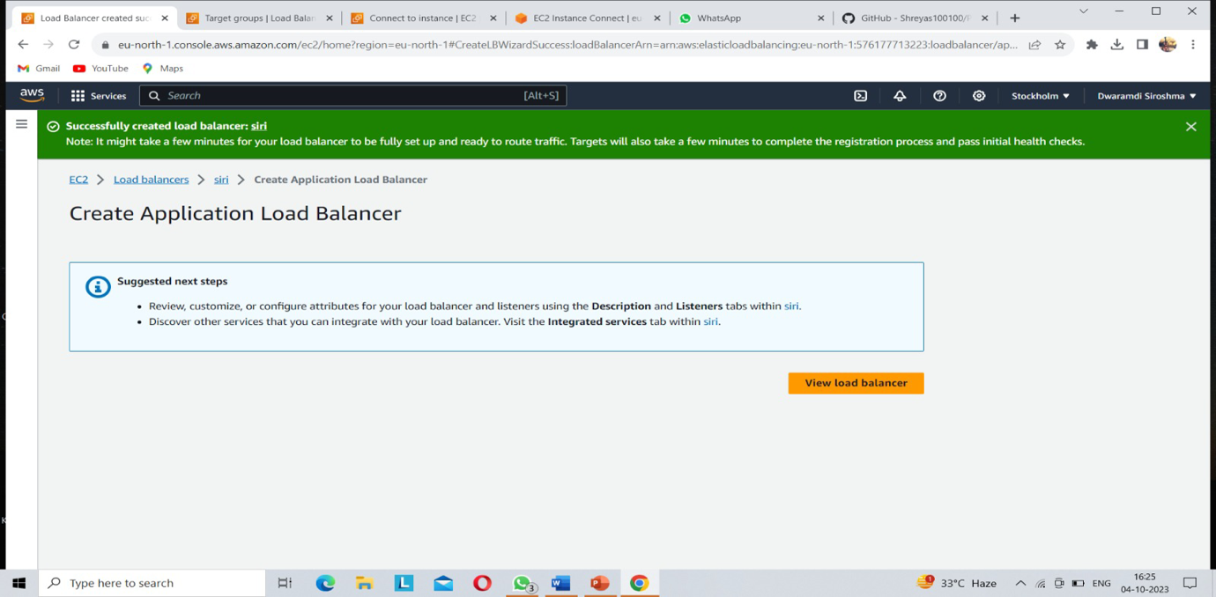

15

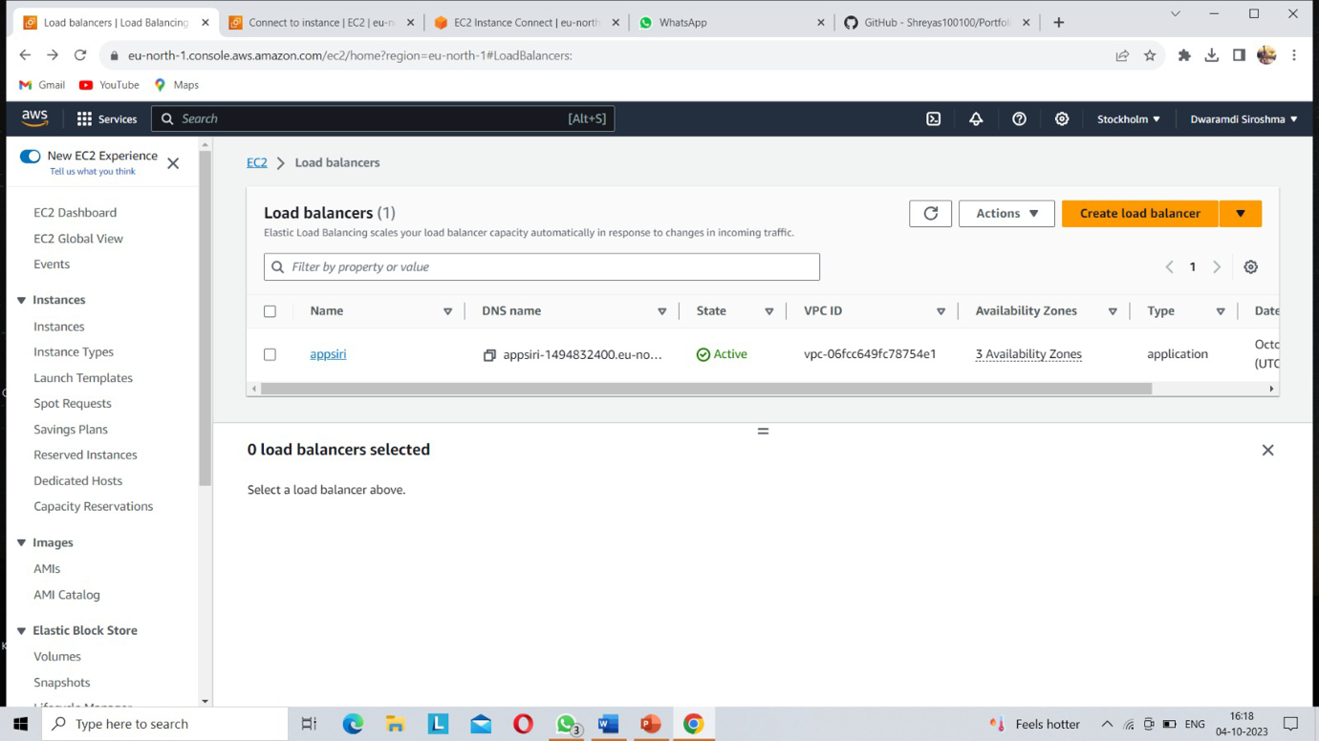

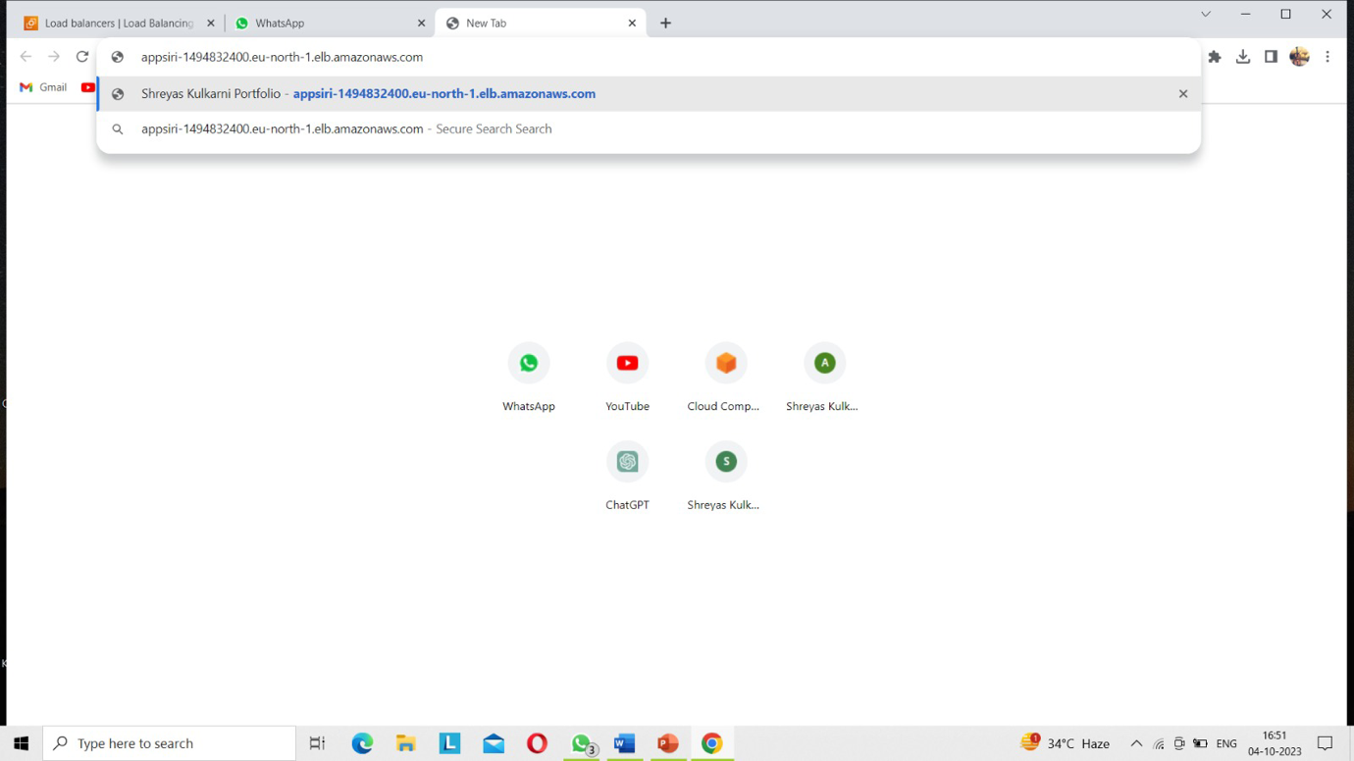

**FIG-4.2.10-SUCCESFULLY DEPLOY WEB APPLICATION IN ALB**

16

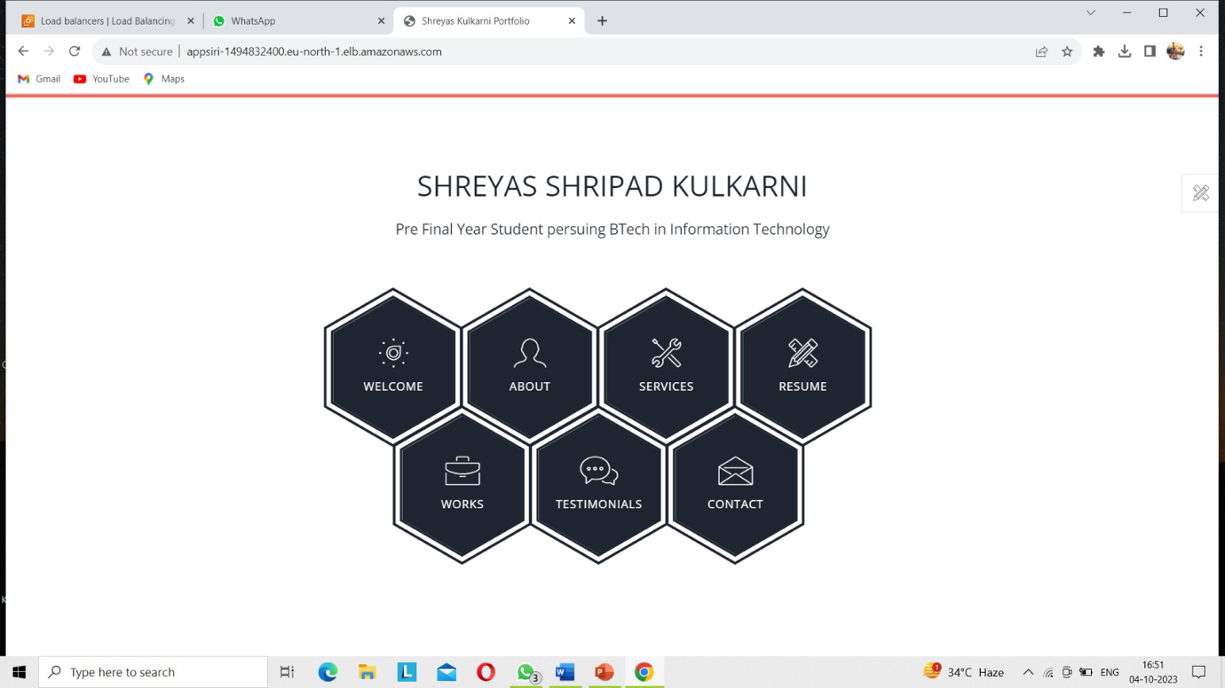

We successfully created Application load balancer deploy the web application by implementing two instances.

17

**4.3.Web Application:**

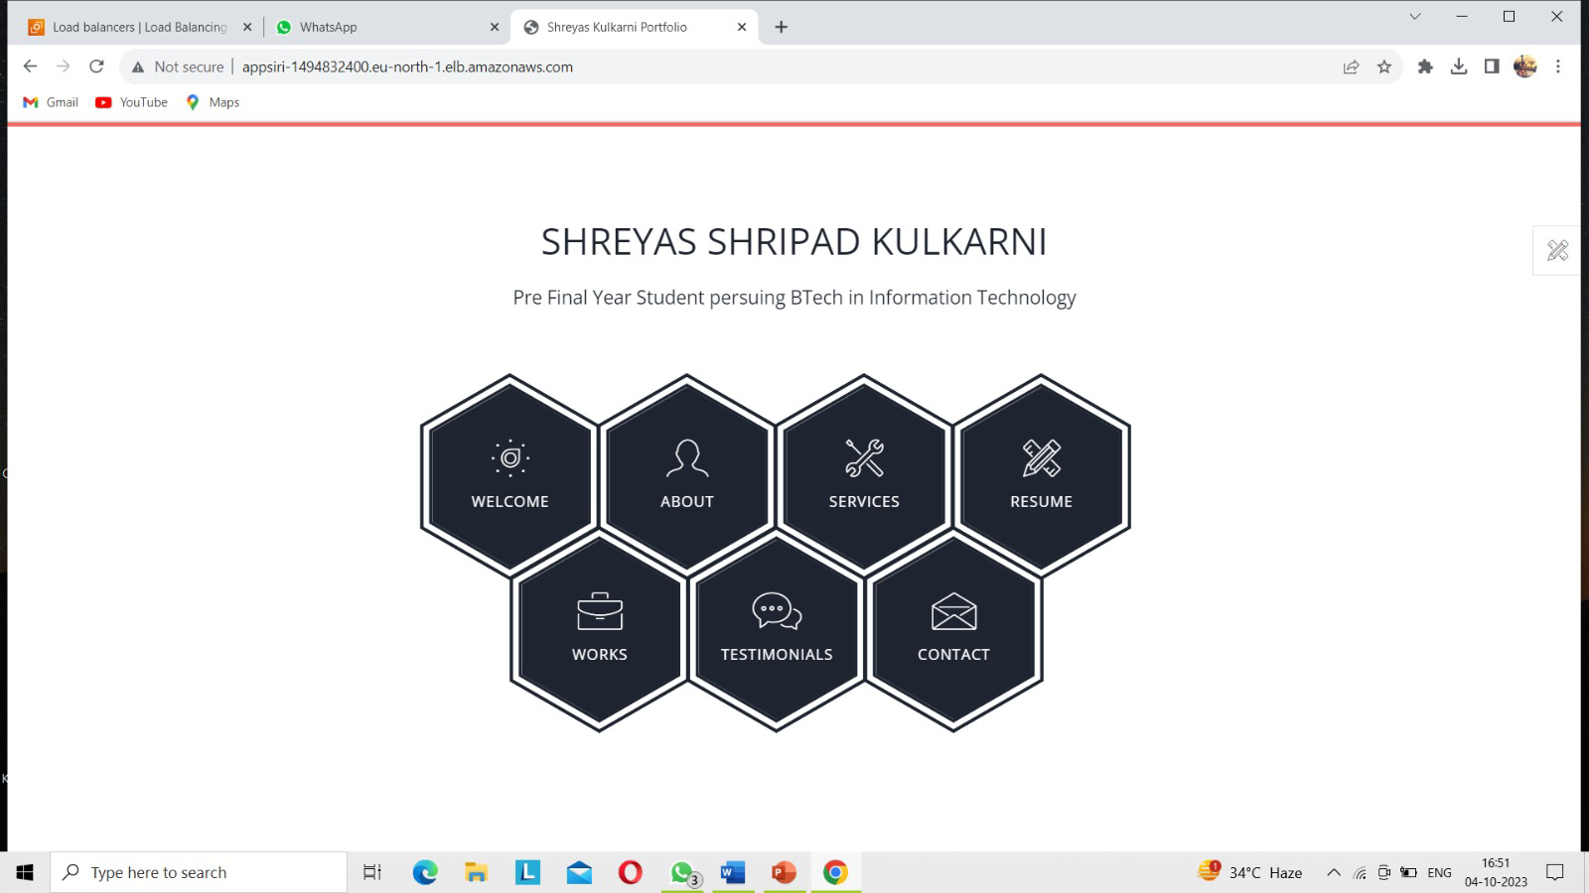

18

**CHAPTER 5**

**CONCLUSION**

We have learnt and understood Cloud Computing, Cloud Service Models, Cloud Deployment Models. We have also deployed a web application on AWS Cloud.Cloud load balancing ensures distributing your site’s traffic to available servers effectively. It prevents downtime or machine breakdown issues while ensuring the applications are available to the client at all times. This article has talked about cloud load balancing and its benefits. If you have any questions about implementing or maintaining your own cloud load balancing solution, reach out to the sales!

**19**

**REFERENCES**

[1] A. S. Hote, "A Review on Load Balancing in Cloud Computing," International Journal of Computer Applications, vol. 107, no. 1, pp. 10-16, 2014.

[2] Amazon Web Services, "Elastic Load Balancing," AWS Documentation, <https://aws.amazon.com/elasticloadbalancing/>, Accessed September 2021.

[3] Y. Zhang, H. Zhang, and L. Sun, "Research on Load Balancing Algorithms in Cloud Computing," 2012 Second International Conference on Cloud and Green Computing, Xiangtan, China, 2012, pp. 42-45.

[4] L. Xue and L. Jie, "An Effective Load Balancing Algorithm for Cloud Computing," 2010 International Conference on Computational Intelligence and Software Engineering, Wuhan, China, 2010, pp. 1-3.

[5] M. Pathan and I. Yaqoob, "Load Balancing in Cloud Computing: A Review," in Advances in Computing and Communications, A. Abraham, V. Snášel, and A. Krömer, Eds. Berlin, Heidelberg: Springer, 2012, pp. 1-10.

[6] Amazon Web Services, "What Is AWS Web Application Firewall?" AWS Documentation, <https://aws.amazon.com/waf/>, Accessed September 2021.

[7] Amazon Web Services, "Elastic Load Balancing Integration with Other AWS Services," AWS Documentation, <https://aws.amazon.com/elasticloadbalancing/features/integration/>, Accessed September 2021.

[8] Amazon Web Services, "What Is Elastic Load Balancing?" AWS Documentation, <https://aws.amazon.com/elasticloadbalancing/what-is-elastic-load-balancing/>, Accessed September 2021.

20